XXX. Czech Championships 2013 in Masters Swimming

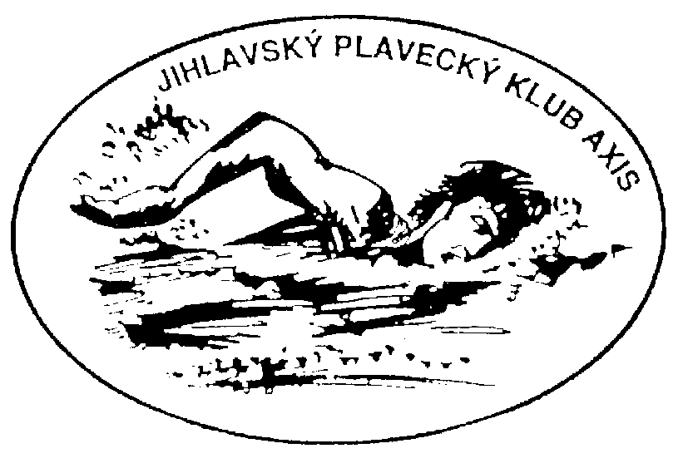

Organizer: Jihlavský plavecký klub Axis

Date : 18th – 19th May 2013

Place: Indoor pool SMJ, E. Rošického 6, Jihlava, Czech Republic
25m, 6 lanes, electronic timing Omega

Registration: Deadline 5th May 2013
Cancellation entries till 13th May 2013

Vladimír Rambousek

Malý Beranov 105
586 03 Jihlava

Tel. : 606830189
E-mail: rambousek@tchibo.cz

Organizer reserves rights to limit entries.

Check-in: Friday 17th May 2013 from 6PM to 8PM in pool area,
Saturday 18th May 2013 from 7:30AM to 8:30AM in pool area and then during the warm-up.

Program:

Saturday 18th May 2013, morning Saturday 18Th May 2013, afternoon
Warm-up at 8:30, Competition at 9:30 Warm-up at 14:00, Competition v 15:00
1,2) 800m free women, men 13) 4x50m free mix
3,4) 200m breast women, men 14,15) 50m free women, men
5,6) 100m back women, men 16,17) 200m fly women, men
7,8) 50m fly women, men 18,19) 100m breast women, men,
9,10) 400m I.M. breast women, men 20,21) 200m free women, men
11,12) 4x50m free relay women, men 22,23) 200m I.M. women, men
24) 4x50m I.M. mix

Sunday 19th May 2013, morning

Warm-up at 8:00am, Competition at 9:00am
25,26) 400m free women, men 33,34) 100m fly women, men
27,28) 50m back women, men 35,36) 200m back women, men
29,30) 50m breast women, men 37,38) 100m I.M. women, men
31,32) 100m free women, men 39,40) 4x50m I.M. women, men

Age groups: A = age 25-29 (1988-1984) G = age 55-59 (1958-1954)
B = age 30-34 (1983-1979) H = age 60-64 (1953-1949)
C = age 35-39 (1978-1974) I = age 65-69 (1948-1944)
D = age 40-44 (1973-1969) J = age 70-74 (1943-1939)
E = age 45-49 (1968-1964) K = age 75-79 (1938-1934)
F = age 50-54 (1963-1959) L = age 80+(1933 and earlier)

Relays: A=100-119 years, B=120-159 years, C=160-199 years, D=200-239 years, E=240-279, F=280-319, G=320 and more. Registration of all relays till end of Saturday morning program, incl. names and age group.

Rankings: The first three competitors in each event and age group will receive diploma. The first three competitors according to the Czech Masters scoring will receive diploma, medal and small price. The highest point performance in women and men category will be also announced.

Party: Evening party will be held on Saturday evening at Gustav Mahler Hotel with dinner, music, dancing and lot of fun.

Entry fees: Entry fee is 65,-CZK for every individual event, 80,-CZK for relays. Party fee is 150,-CZK incl. dinner. Party booking together with events registration.

Accommodation: is possible to order in Gustav Mahler Hotel (www.hotelgmahler.cz), price 500,-CZK per person/night inc. breakfast. Email to recepce@hotelgmahler.cz, in order please note „Mistrovstvi CR masters“. Other possibility is Vila I. a II. (www.ubytovani-jihlava.cz), price from 178,-CZK per person/night. Orders with note „Mistrovstvi CR masters“ send to email rezervace@ubytovanivevile.cz . Orders send to 13th May 2013

Thank you in advance for your plentiful attendance and see you in Jihlava.

